**Rafey Saleem**

Medikart E-Commerce website (MErn Project)

Project Documentation: MEDIKART

# 1. Project Overview

MEDIKART is a full-stack healthcare e-commerce platform designed to streamline the experience of buying medical supplies, connecting users with healthcare professionals, and managing orders efficiently. It features a modern, responsive design, secure authentication flow, and a real-time support system to enhance user interaction.

# 2. Tech Stack (MERN)

Frontend: React.js (Hooks, Router, Context API)

Backend: Node.js, Express.js

Database: MongoDB (via Mongoose)

Real-time: Socket.io

Emailing: EmailJS

Storage: LocalStorage (Frontend), MongoDB (Backend)

Styling: Custom CSS, React Bootstrap, FontAwesome

# 3. Key Features

* Customer-facing storefront with cart and checkout
* Admin dashboard for managing users, products, and orders
* Real-time chat system for customer support
* Email notifications for order confirmation
* Form validation and user feedback
* Dark/light theme toggling
* Responsive and mobile-friendly design
* Secure login/logout with session management

# 4. Pages Overview

## About Page

* Showcases the company’s story, mission, values, and team.
* Includes tabs for each section with smooth transitions.
* Fetches team data and milestones dynamically from the backend API.
* Animated statistic counters for visual appeal.

## 

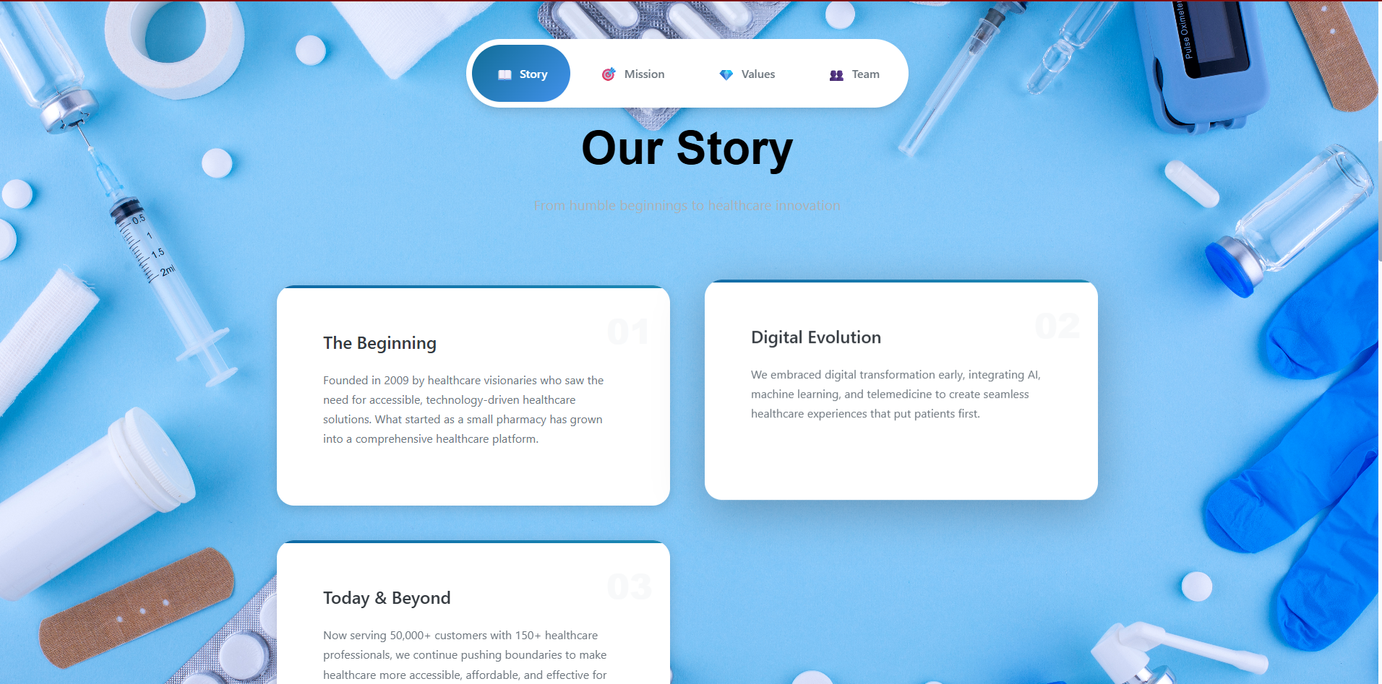

**User Management Page**

* **Purpose:**  
  Admin interface to manage all user accounts (customers, doctors, pharmacists).
* **Key Features:**
  + View/edit user profiles (name, email, role, status)
  + Create new user accounts
  + Enable/disable accounts
  + Filter/search users by role/status
  + Pagination for large user lists
* **Components Used:**
  + User table with sortable columns
  + Role dropdown filters (Admin/Doctor/Patient)
  + Status toggle switches
  + Add/Edit user modals
  + Bulk action controls
* **API Interactions:**
  + GET /api/users – Fetch all users
  + POST /api/users – Create new user
  + PUT /api/users/:id – Update user
  + DELETE /api/users/:id – Deactivate user

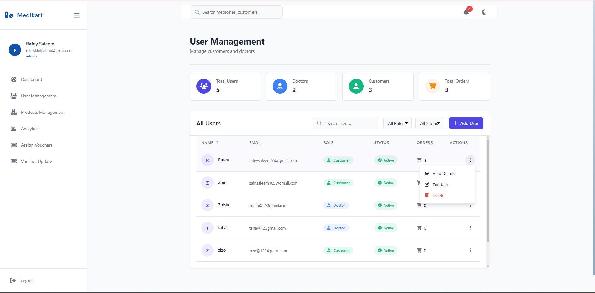

**Product Management Page**

* **Purpose:**  
  Manage pharmacy inventory and product listings.
* **Key Features:**
  + Add/edit medicine details (name, price, category, stock)
  + Upload product images
  + Set prescription requirements
  + Manage categories (OTC/Prescription)
  + Low stock alerts
* **Components Used:**
  + Product data table with filters
  + Rich text editor for descriptions
  + Image upload widget
  + Inventory status badges
  + Bulk import/export tools
* **API Interactions:**
  + GET /api/products – Fetch products
  + POST /api/products – Add new product
  + PATCH /api/products/:id – Update stock
  + DELETE /api/products/:id – Remove product

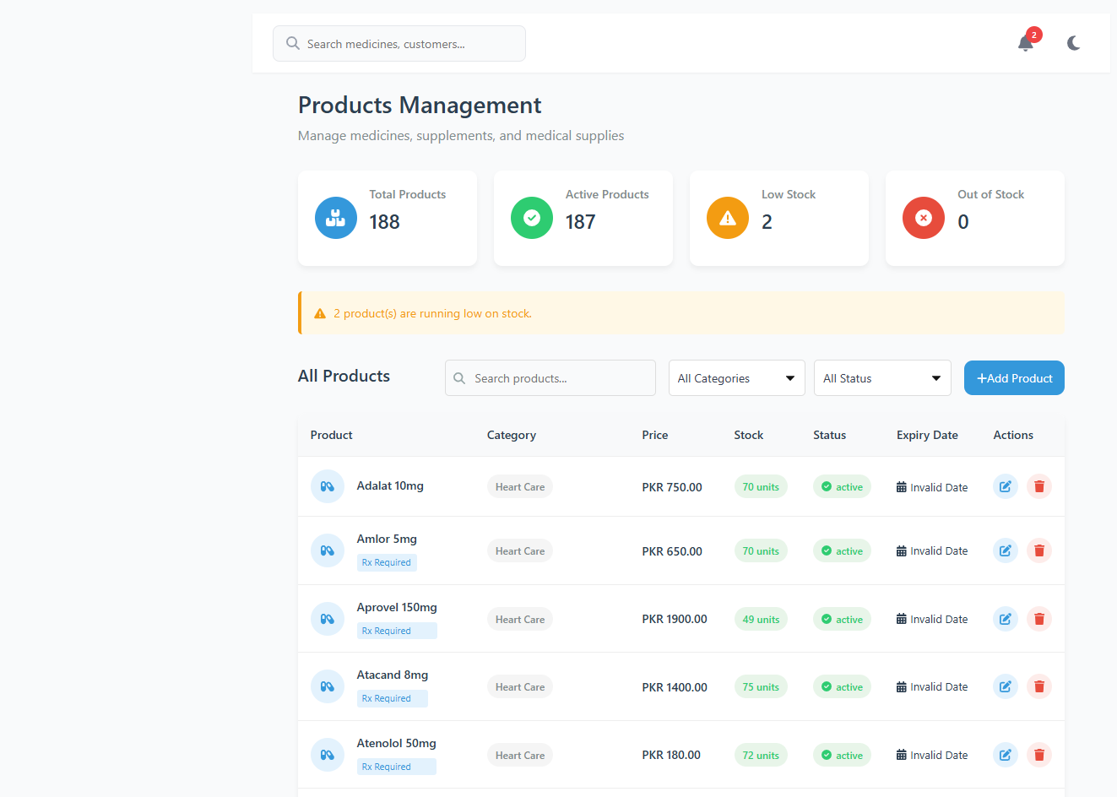

**Voucher Assignment Page**

* **Purpose:**  
  Assign discount coupons to specific users.
* **Key Features:**
  + Select users from dropdown
  + Choose voucher type (% or fixed discount)
  + Set expiry dates
  + Apply bulk assignments
  + View assignment history
* **Components Used:**
  + User selection autocompletes
  + Voucher type radio buttons
  + Date picker for expiry
  + Assignment history log
* **API Interactions:**
  + GET /api/vouchers/available – Get unused vouchers
  + POST /api/vouchers/assign – Assign to user
  + GET /api/vouchers/assigned – View assignments

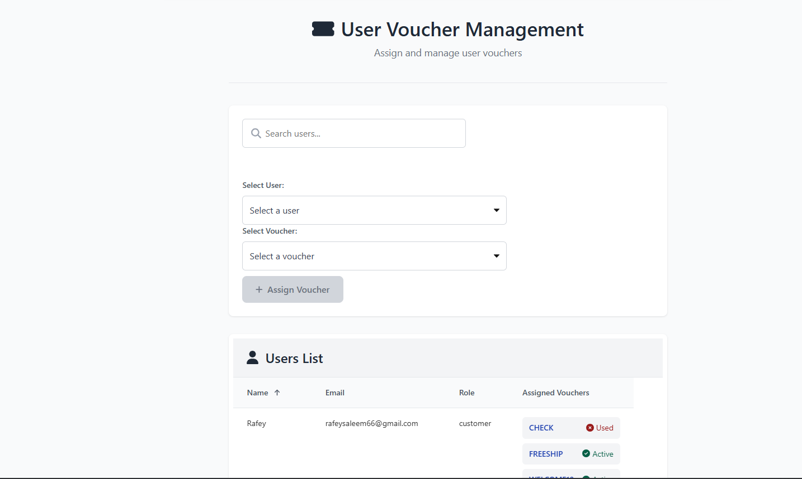

**Voucher Update Page**

* **Purpose:**  
  Create and manage discount voucher codes.
* **Key Features:**
  + Generate new voucher codes
  + Set discount rules (min order, categories)
  + Track redemption stats
  + Disable/reenable vouchers
  + CSV export functionality
* **Components Used:**
  + Voucher code generator
  + Rule condition builder
  + Usage statistics charts
  + Status toggle switches
* **API Interactions:**
  + POST /api/vouchers – Create voucher
  + PUT /api/vouchers/:code – Update rules
  + GET /api/vouchers/usage – Get redemption data

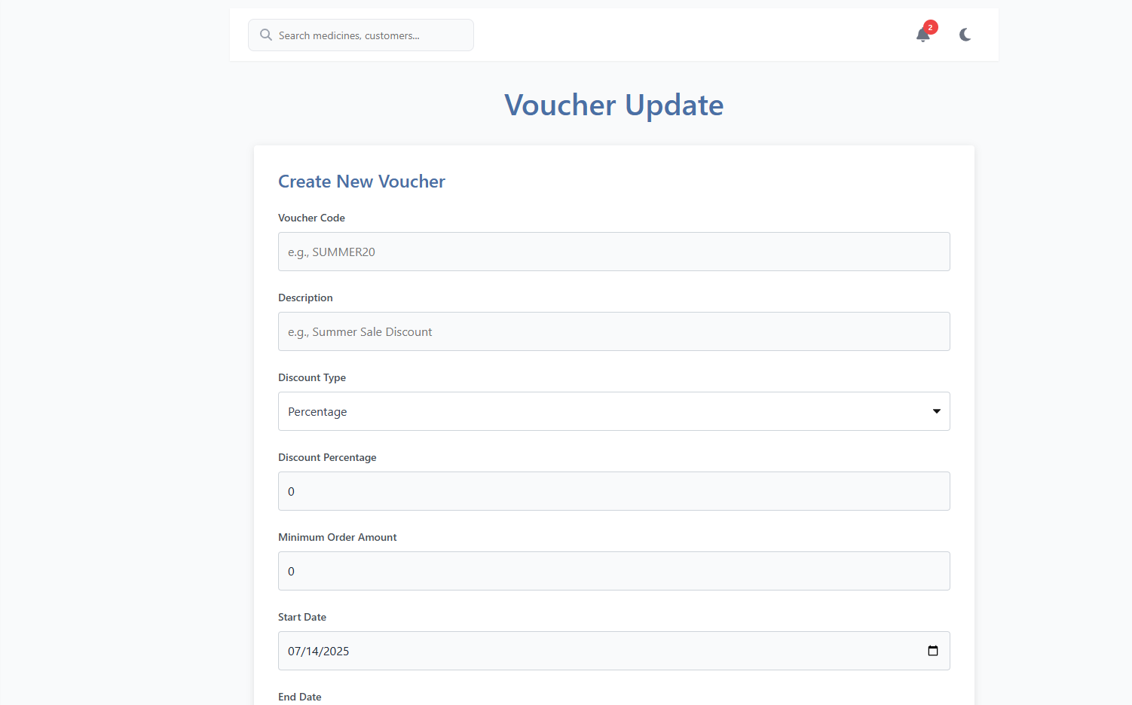

## Admin Dashboard

* Main admin interface showing stats like total customers, products, and orders.
* Includes sections for user and product management.
* Displays recent activity logs and allows admin actions (edit/delete).

## 

## Analytics Page

* Shows detailed sales metrics, top products, revenue charts.
* Displays order history and breakdown by category.

## Cart Page

* Allows users to add/remove items, adjust quantities.
* Applies promo codes and calculates totals (tax, shipping).
* Saves cart data in localStorage for persistence.

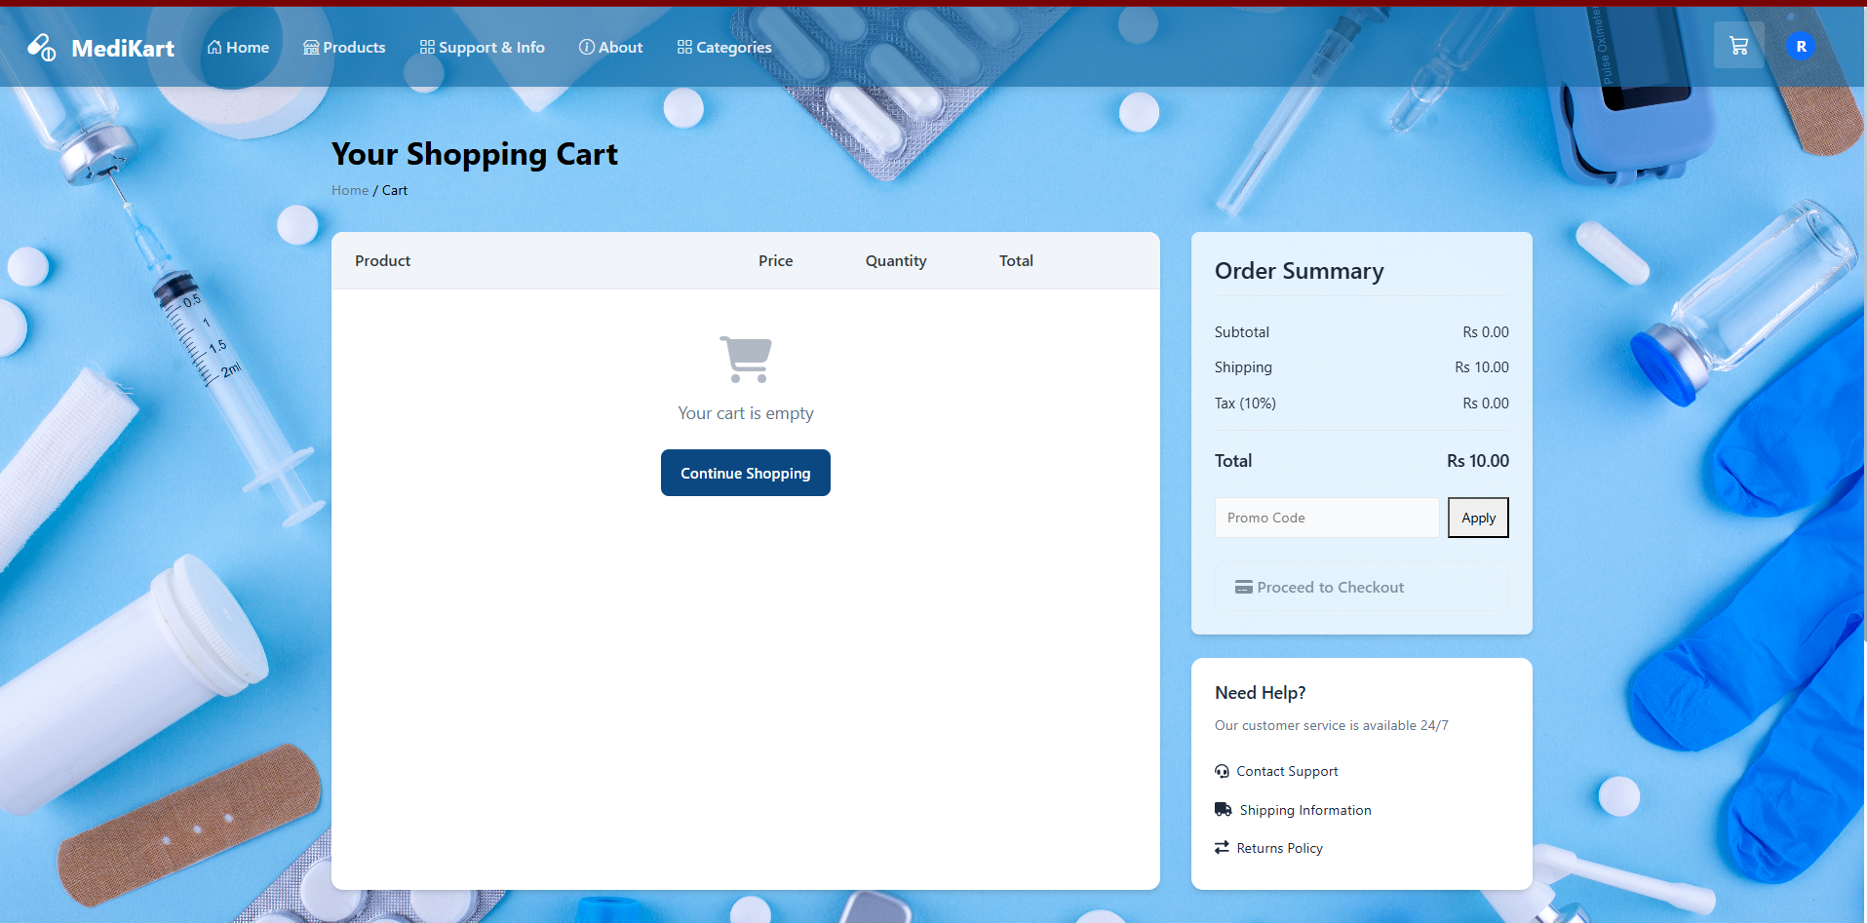

## Chat Window

* Real-time messaging between users and doctors/support team.
* Online/offline status indicators.
* Typing indicator, message history.

## Checkout Page

* Final step of order process: shipping, payment, review.
* Validates inputs and processes payments.
* Sends order confirmation via EmailJS.

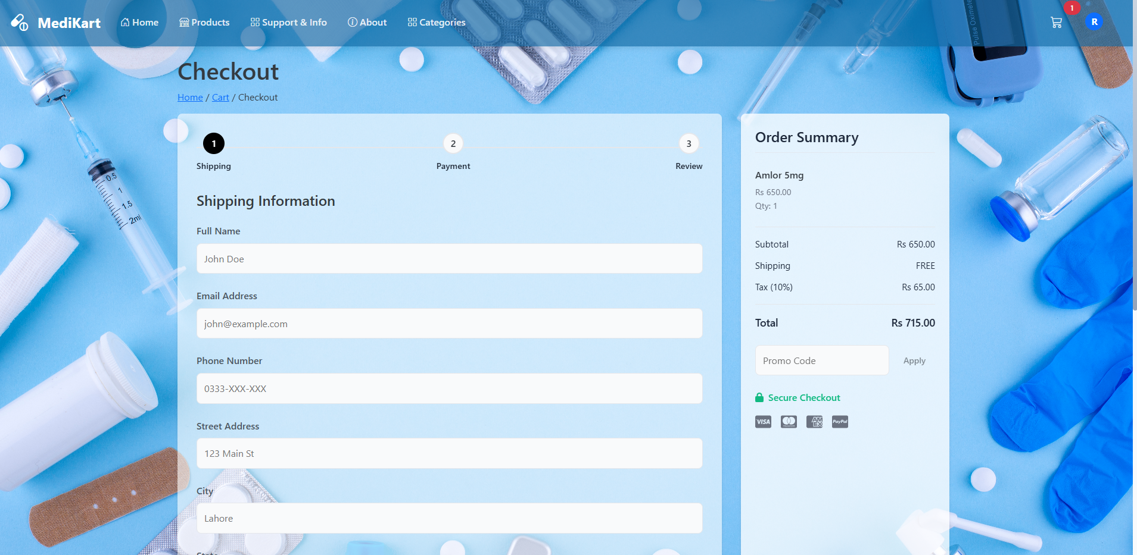

## Contact Page

* Users can submit support queries with selected topics.
* Form validation and email submission.
* Shows contact details (phone, address, email).

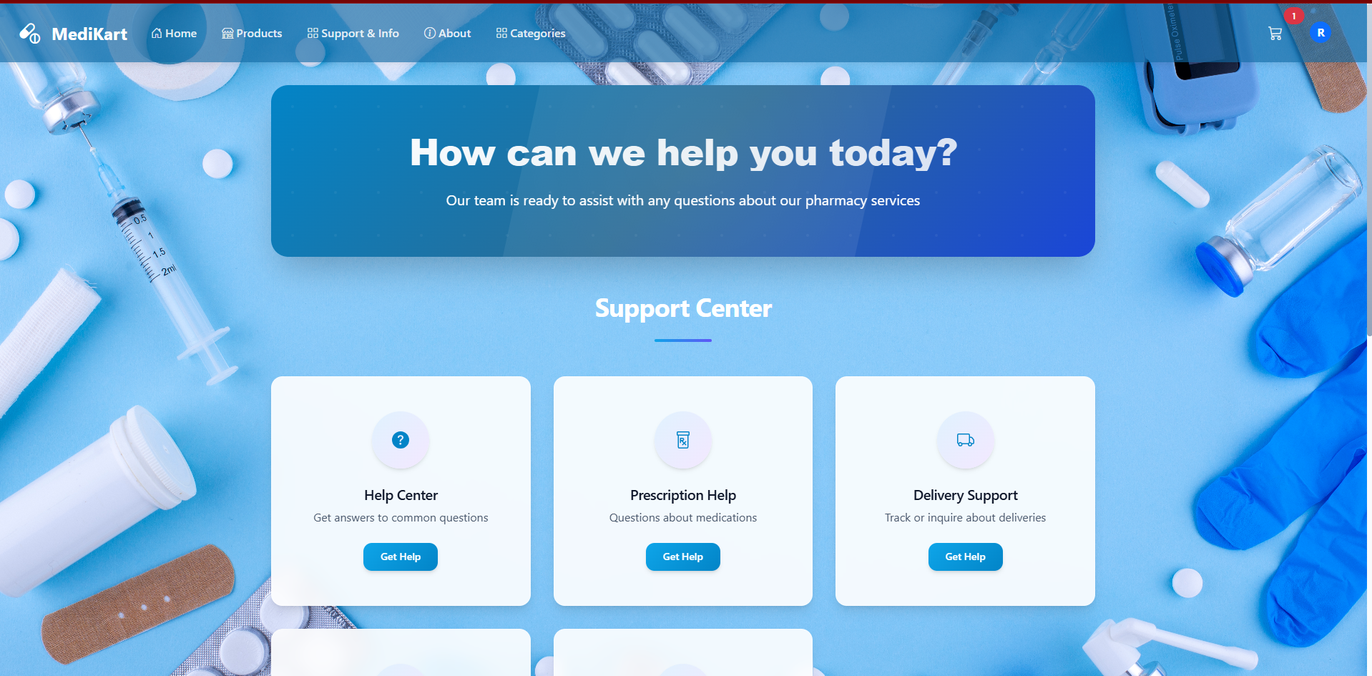

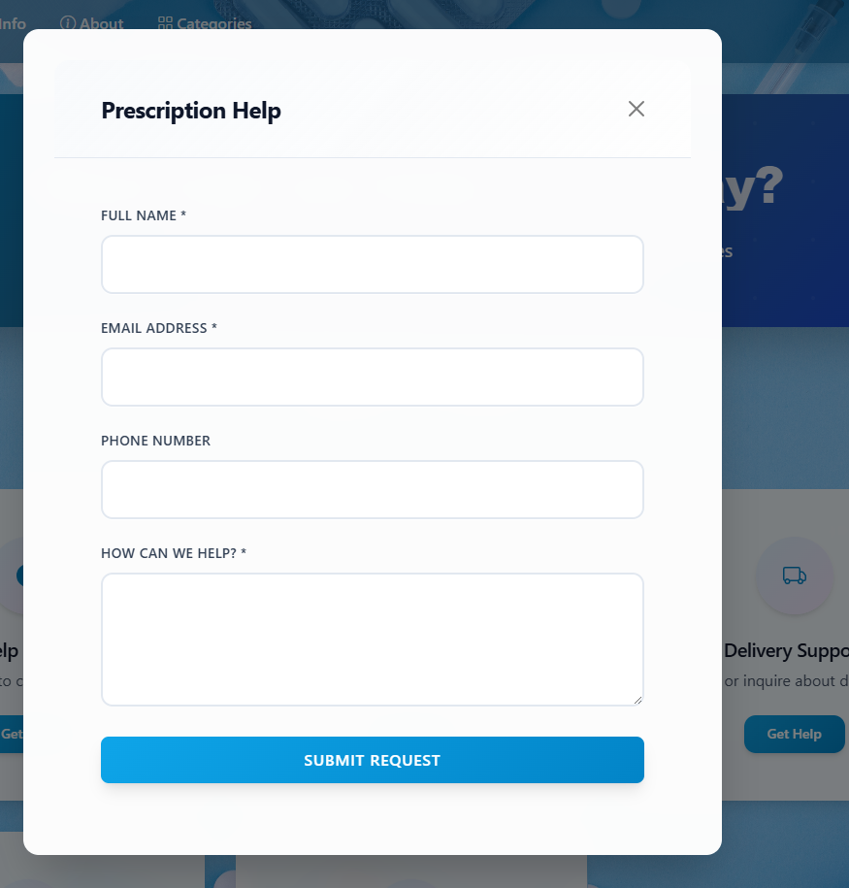

## Home Page

* Landing page with hero section, services, testimonials, stats.
* Highlights featured product categories.
* Includes a responsive carousel.

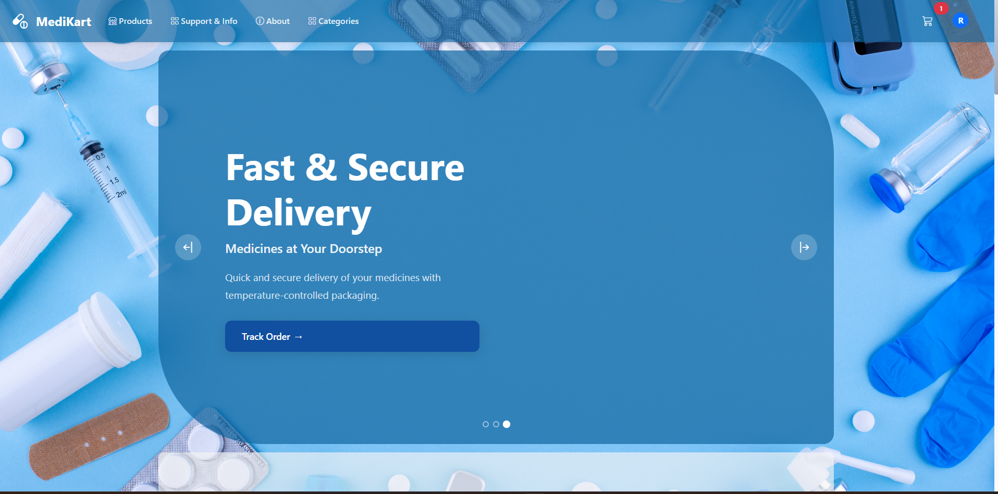



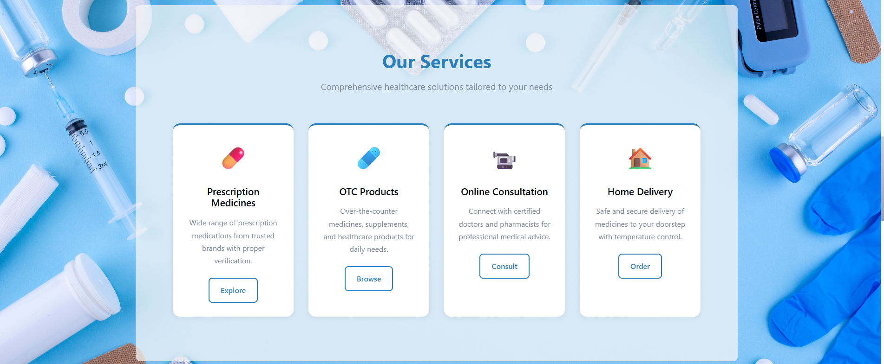

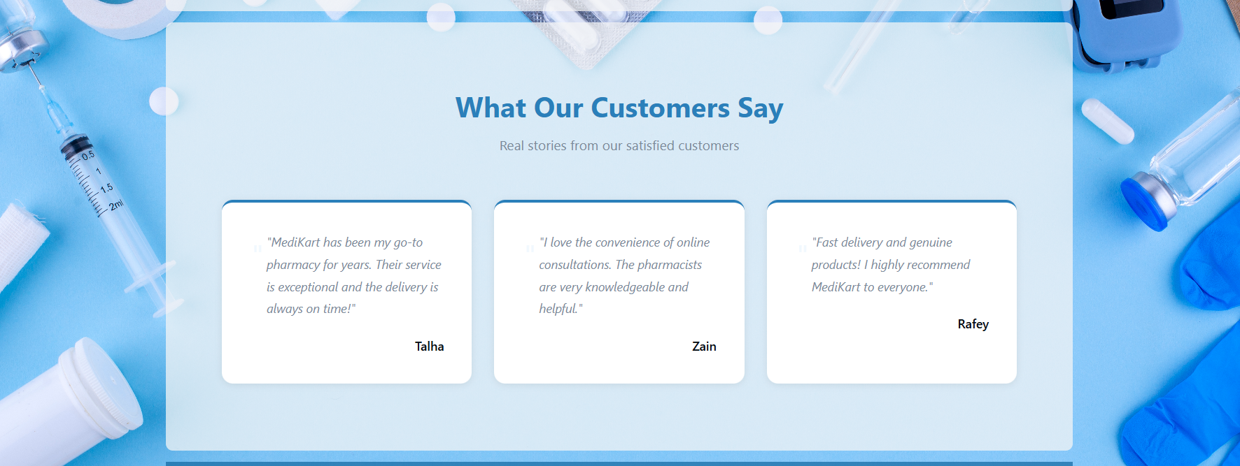

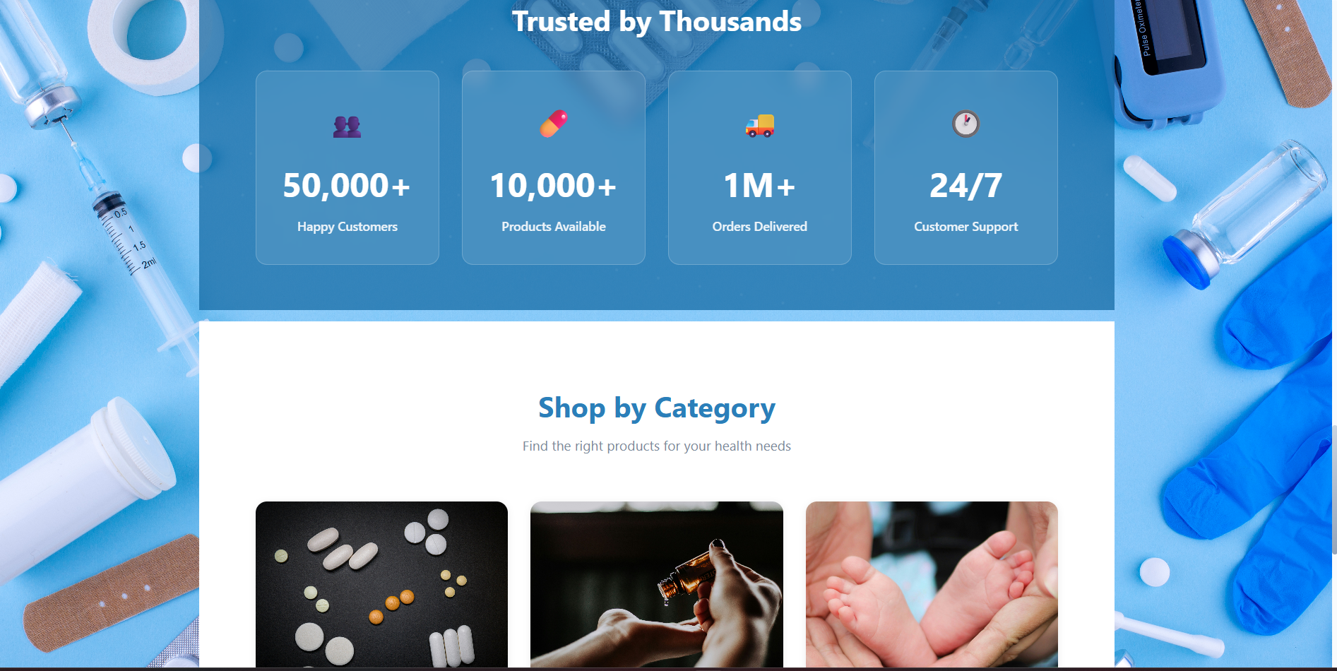

## Login Page

* User login form with email and password.
* Validates input and connects to backend for authentication.
* Video background for visual appeal.

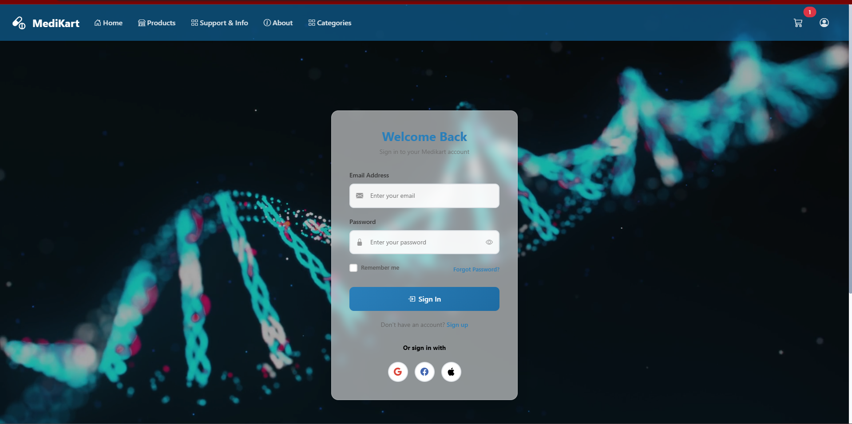

**Same for Sign up:**

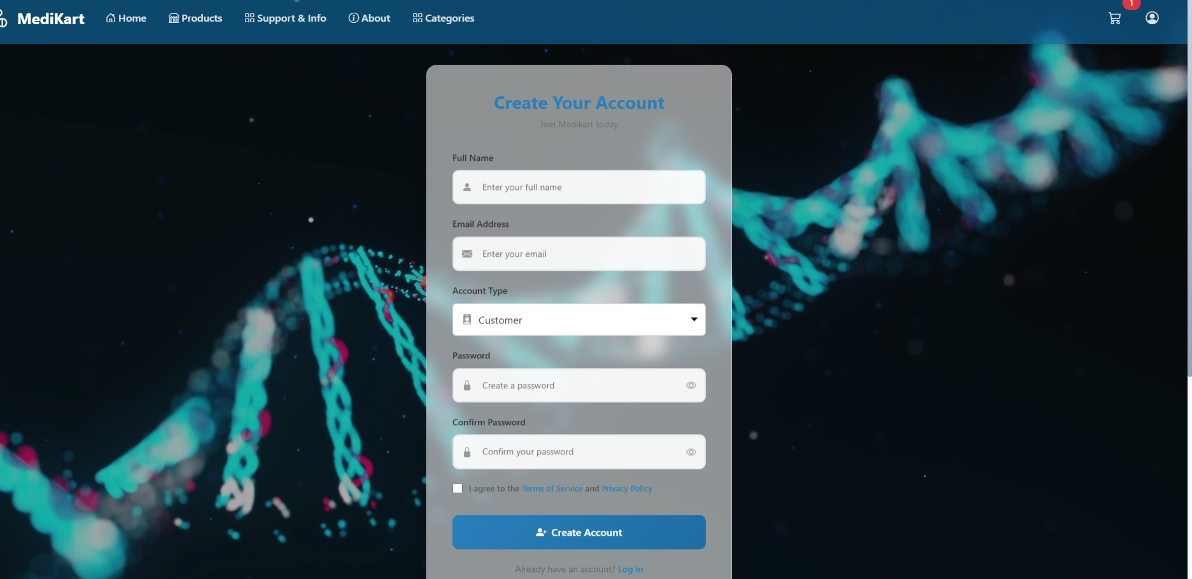

## Navbar

* Persistent top navigation bar across the site.
* Includes dropdowns, cart icon with count, and user profile.
* Changes based on login state.

## 

## Policy Page

* Displays detailed privacy policy and terms.
* Structured sections with legal formatting.
* Navigation back to home page.

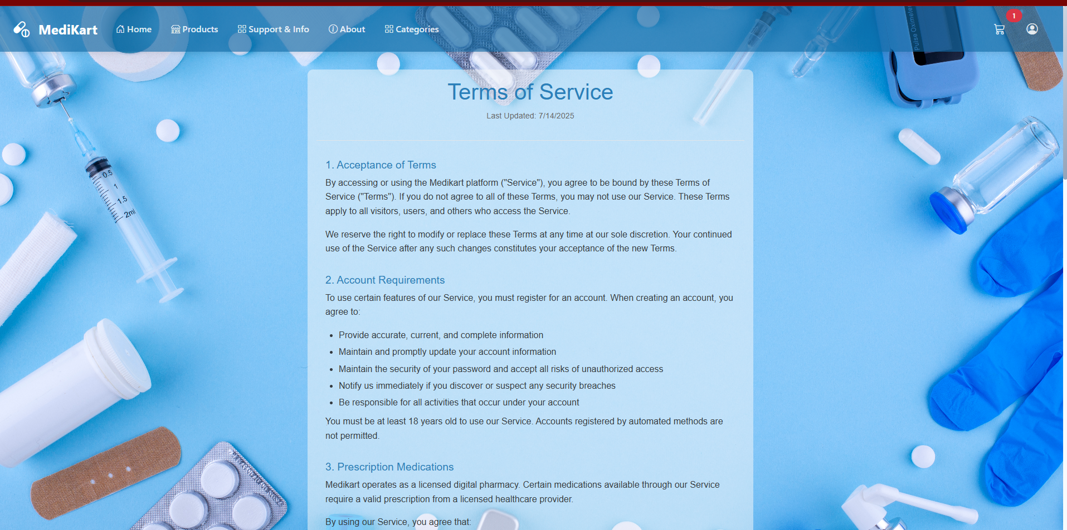

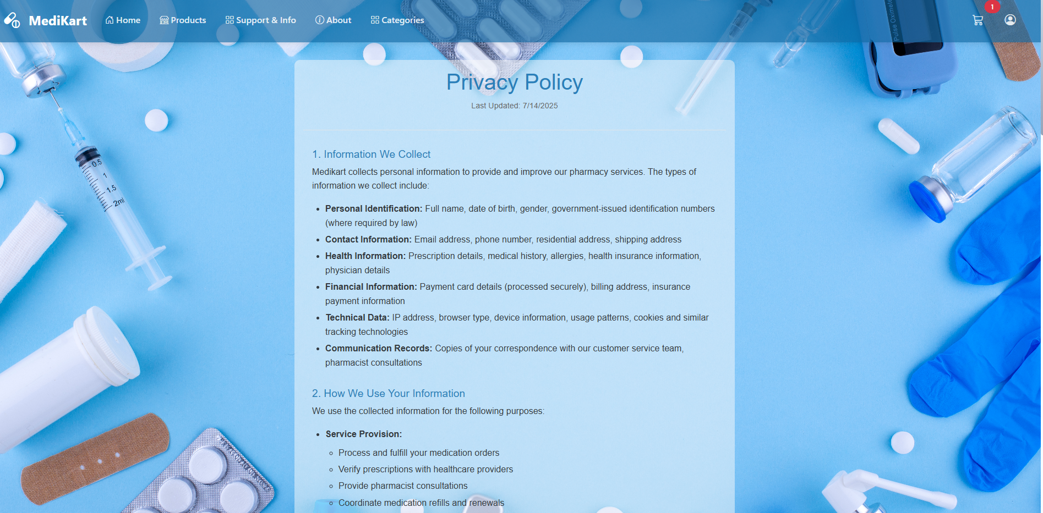

# 5. Architecture & Design Patterns

* Component-based design: Each feature is encapsulated within reusable, isolated components.
* React Context API: For global state like theme, auth state, and cart.
* React Router: For handling multi-page navigation.
* Service Layer: For backend communication via API abstraction.
* Environment Variables: For secure API keys and endpoints.

# 6. Third-party Libraries & Tools

React Router: Routing between pages

Socket.io: Real-time chat system

EmailJS: Email delivery

FontAwesome: Icons for UI

React Bootstrap: Modals and responsive components

LocalStorage: Persistent cart and session data

# 7. Conclusion

MEDIKART is a robust, scalable healthcare e-commerce platform built on the MERN stack. It offers a comprehensive solution for online pharmaceutical retail, blending user-centric design with powerful admin tools and real-time communication. Its modular architecture ensures easy maintainability and future scalability.